**NAME: AQSA TAUHEED (2303-KHI-DEG-011)**

**PAIRING WITH : MAVIA ALAM KHAN (2303.KHI.DEG.017)**

**&**

**MOHAMMAD HUSSAM(2033.KHI.DEG.020)**

_____________________________________________________________________________________

**ASSIGNMENT NO : 3.3**

Perform k-means clusterization on the Iris  
dataset. Repeat the procedure on the  
dataset reduced with PCA, and then  
compare the results.

**Solution:**

**Step#1:**

First of all we have to import the necessary libraries.

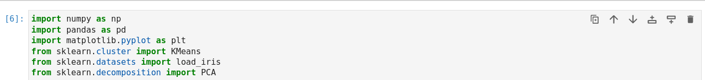

**Step#2:**

After that we load the iris data set.

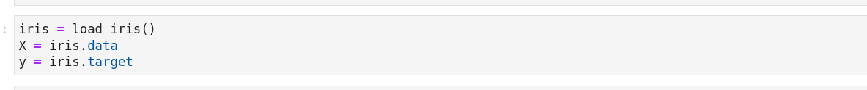

**Step#3:**

We Performed k-means clustering with 3 clusters on the original dataset.



**Step # 4:**

Applying PCA to reduce the dimensionality of the dataset to 2.



**Step # 5:**

Performing k-means clustering with 3 clusters on the reduced dataset.



**Step # 6:**

First we plot the clustering results for the original dataset.

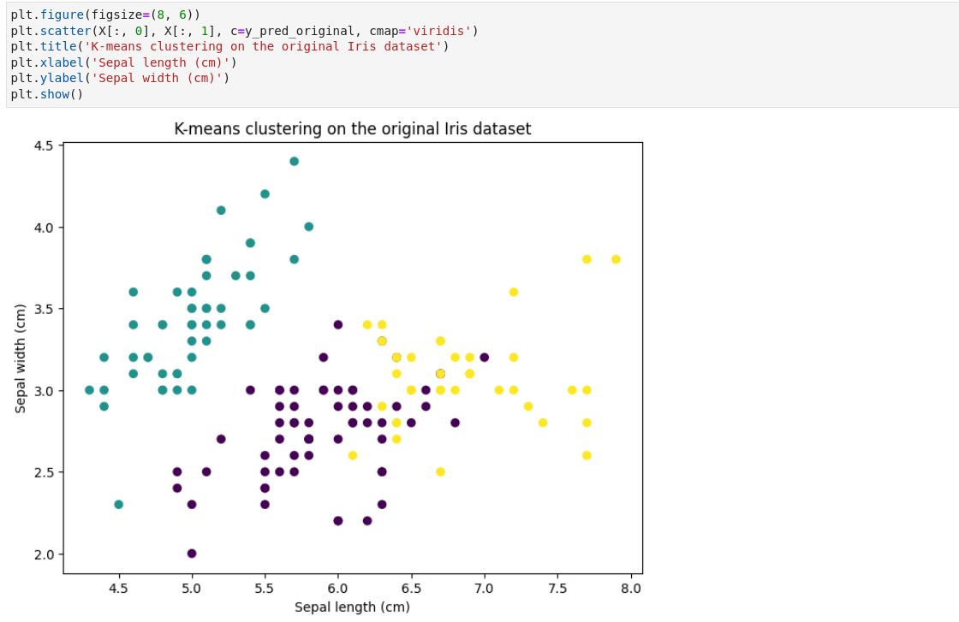

After that Ploting the clustering results for the reduced dataset.

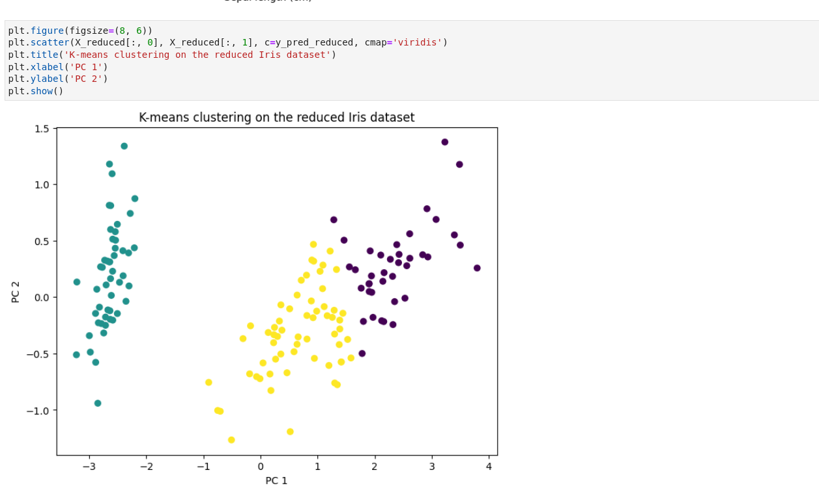

**Comparision:**

K- means clustering on original:

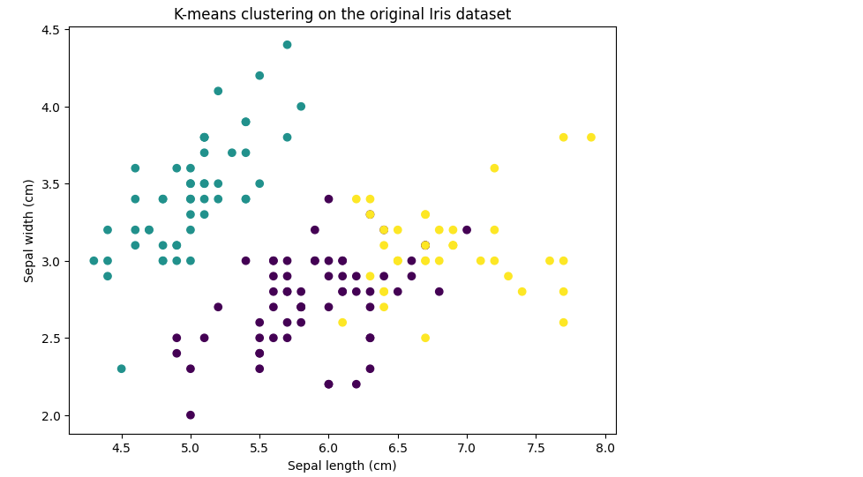

On reduced iris dataset:

